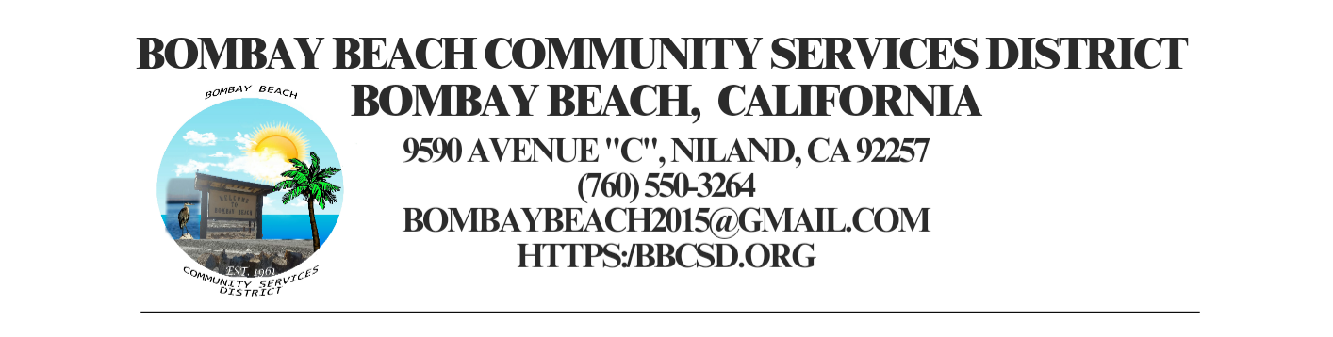

**REGULAR SCHEDULED MEETING**

**Board of Directors**

Paedrin Fusco – Board Chair Date: December 19, 2024

Candace Youngberg – Vice Chair Time: 6:00 PM

Cameron Leslie Place: 9590 Avenue C Bombay Beach

Teresa Lamer Niland, CA 92257

Steven Johnson

1. **CALL TO ORDER:**
2. Pledge Allegiance to the Flag
3. Roll Call to determine Quorum
4. **APPROVAL OF THE AGENDA:** Board will approve the agenda for the Regular Meeting for December 19, 2024, as is or delete/clarify any item on the agenda.
5. **APPROVAL OF MEETING MINUTES FROM November 21, 2024:**
6. **CONSENT AGENDA:** “A Consent Agenda may be presented by the Board President at the beginning of a meeting. Items may be removed from the Consent Agenda on the request of any one member. Items not removed may be adopted by general consent without debate. Removed items may be taken up either immediately after the consent agenda or placed later on the agenda at the direction of the assembly”.
7. FINACIAL REPORT: Report on financial status of the District as of November 30, 2024. Still Pending Access to all Accounts
8. The Board will approve payment of accounts payable in the form of Demands to the County. Copy of list of Demands is available upon request.
9. The process to establish an Emergency Response Unit. (ERU Admin) No Update
10. What to do with the Large Water Pump that belongs to the District. (ERU Admin)
    1. No Update
11. **OPEN FORUM/PUBLIC COMMENT:** This is an opportunity for members of the public to address the Board on any subject matter within the Board’s jurisdiction, but not an item on the published agenda. Public Comment on agenda items will be allowed when the agenda item is called by the Board. Please make comments at podium, state name and limit comments to 3 minutes.
12. **ITEMS REMOVED FROM CONSENT AGENDA:**
13. **OLD BUSINESS – DISCUSSION ACTION ON THE FOLLOWING:**
14. The Board will hear an update to construct a fence to separate the trash dumpsters lot from the adjoining lot. (Youngberg) (Item introduced 06/15/52023)
15. The Board will consider adopting resolution 2024-01-01 Uniform Public Construction Cost Accounting Act. (Youngberg) (Item introduced 09/13/2023)
16. The Board will hear an update on the establishment of a local mass texting or information dissemination service for Bombay Beach Residents. (Hernandez) (Introduced 01/18/2024)
17. Park Grant Application Process. (Youngberg)
18. District Kitchen Remodel Project. (Youngberg)
19. The Process to Acquire the Fire Department Building at Bombay Beach. (Fusco)
20. The Process to establish a Flood Response Unit for Bombay Beach. (Youngberg/Fusco)
21. Avenue A Beautification Update. (Youngberg)
22. The Board will hear an update and discuss the offers for the Districts Fire Apparatus listed on GovDeals for sale/auction. (Youngberg).
23. The Board will discuss the purchase of a water bowser or like option for the ERU to assist with Fire Suppression. (ERU Admin)
24. The Board will discuss if continuing use of District supplied cell phone service is still required. (Hernandez)
25. The Board will discuss looking at other payroll agencies to provide District Payroll Service. (Introduced 06/20/2024)
26. The Board will discuss the process of renaming Avenue E to Ernie Street. (Czar/Youngberg) (Introduced 06/20/2024)
27. **NEW BUSINESS – DISCUSSION/ACTION ON THE FOLLOWING:**
    1. Discussion by Board to adopt Cleaning Checklist (weekly and monthly). – Fusco
    2. Discussion by Board to draft letter to send to different agencies and companies with district letterhead for easier access to turn over control of accounts to Acting Interim Secretary Director Youngberg and take Auggies name off of the accounts. – Fusco
    3. Discussion by Board to create an amendment for the tree grant on Avenue A to allow Director Fusco to sign instead of Auggie
    4. Discussion with Roque Barros from IV Wellness foundation to create Action Plan for the $25,000.00 Awarded to the District for the work they have been doing in the community.
28. **COMMUNITY REPORTS:**
29. **BOARD DISCUSSION/DIRECTIVES:**
30. **DIRECTOR REPORTS:**
31. **ADJOURNMENT:**