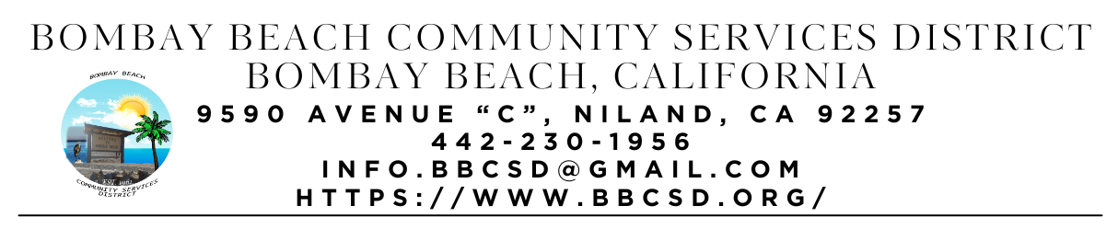
REGULAR SCHEDULED MEETING AGENDA
Board of Directors: |  | Meeting Information:
Paedrin Fusco – Board Chair  Cameron Leslie – Vice Chair  Robin Booth  Teresa Lamer  Steven Johnson |  | Date: April 17, 2025  Time: 6:00 PM  Place: 9590 Avenue C  Niland, CA 92257

- CALL TO ORDER:
  - Pledge Allegiance to the Flag
  - Roll Call to determine Quorum

- APPROVAL OF THE AGENDA: Board will approve the agenda for the Regular Meeting for April 20, 2025, as is or delete/clarify any item on the agenda.

- APPROVAL OF THE MEETING MINUTES: Board will approve the Minutes for Special Called Meeting on March 27, 2025, as is or delete/clarify any item on the minutes.

- OPEN FORUM/PUBLIC COMMENT: This is an opportunity for members of the public to address the Board on any subject matter within the Board’s jurisdiction, but not an item on the published agenda. Public Comment on agenda items will be allowed when the agenda item is called by the Board. Please make comments at podium, state name and limit comments to 3 minutes.

- CONSENT AGENDA: “A Consent Agenda may be presented by the Board President at the beginning of a meeting. Items may be removed from the Consent Agenda on the request of any one member. Items not removed may be adopted by general consent without debate. Removed items may be taken up either immediately after the consent agenda or placed later on the agenda at the direction of the assembly”.
  - FINANCIAL REPORT: Report on financial status of the District as of March 31, 2025
    - Bank of America Account Ending in 1946 - $20,632.19
    - Bank of America Account Ending in 6398 - $666.76
    - Bank of America Account Ending in 5949 - $821.46
    - Bank of America Account Ending in 8163 - $819.89
    - 5 Star Account Ending in 3549 – $29,970.00
    - 5 Star Account Ending in 3557 - $52,939.58
    - Total Amount of District Funds - $105,849.88
  - The Board will approve payment of accounts payable in the form of Demands to the County. Copy of list of Demands is available upon request.
  - The process to establish an Emergency Response Unit. (ERU Coordinator and ERU ADMIN)
  - The Board will hear an update on Process to Acquire the Fire Department Building at Bombay Beach. (Fusco)
  - What to do with the Large Water Pump that belongs to the District. (ERU Admin)
  - The Board will consider adopting resolution 2024-01-01 Uniform Public Construction Cost Accounting Act. (Youngberg) (Item introduced 09/13/2023)
  - The Board will hear an update on the establishment of a local mass texting or information dissemination service for Bombay Beach Residents. (Youngberg - Assumed responsibility 12/19/24)
  - The Board will hear an update and discuss the offers for the Districts Fire Apparatus listed on GovDeals for sale/auction. (Youngberg).
  - Approval of Consent Agenda

- ITEMS REMOVED FROM CONSENT AGENDA:

- OLD BUSINESS – DISCUSSION/ACTION ON THE FOLLOWING:
  - The Board will hear an update on Constructing a fence to separate the trash dumpsters lot from the adjoining lot. (Youngberg) (Item introduced 06/15/2023)
  - The Board will hear an update on Park Grant (Youngberg)
  - The Board will hear an update on District Kitchen Remodel Project. (Booth – Took over project 02/2025)
  - The Board will hear an update on the Avenue A Beautification Update. (Youngberg)
  - The Board will hear an update on Looking at other payroll agencies to provide District Payroll Service. (Youngberg/Johnson) (Introduced 06/20/2024)
  - The Board will provide an update on Applying for the EPA Thriving Communities Grant (Fusco/Youngberg) (Introduced 01/16/2025)
  - Board will hear an update on Building a fenced in Dog Park Area for visitors to the Park and Community Center (Fusco/Youngberg)(Introduced 01/16/2025)
  - The Board will hear an update on the Purchase and Installation of Security Camera System offered to the District by Junior (Introduced 01/16/2025)
  - The Board will hear an update on Replacing and or repair of bulletin boards at each mailbox area in town for easier sharing of information (Introduced 01/16/2025)

- NEW BUSINESS – DISCUSSION/ACTION ON THE FOLLOWING:
  - The Board will discuss sponsoring Portable Toilet/s to be left on Avenue E for the off Season.
  - The Board will discuss adding a Refundable Deposit to the Agreement for Use of the Community Center and Park by others.

- COMMUNITY REPORTS:
  - Upcoming Events:

- BOARD DISCUSSION/DIRECTIVES:

- DIRECTOR REPORTS:

- ADJOURNMENT:

