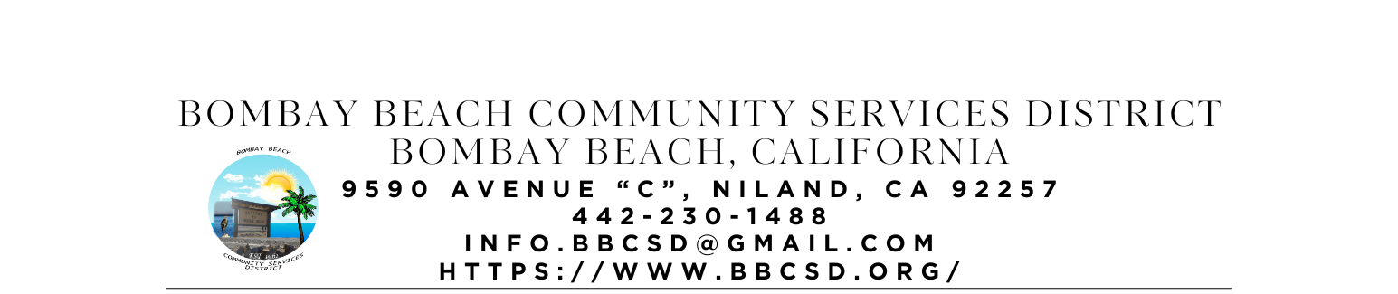
REGULAR SCHEDULED MEETING AGENDA
BOARD OF DIRECTORS
CAMERON LESLIE – BOARD CHAIR Date: JANUARY 16, 2026
ROBIN BOOTH – VICE CHAIR Time: OPEN SESSION: 7:00 PM
THERESA LAMER
STEVEN JOHNSON Place: 9590 Avenue C
PAEDRIN FUSCO Niland, CA 92257

- CALL TO ORDER:
  - Pledge Allegiance to the Flag
  - Roll Call to determine Quorum

- APPROVAL OF THE AGENDA: Board will approve the agenda for the REGULAR SCHEDULED MEETING FOR JANUARY 16, 2026, as is or delete/clarify any item on the agenda.

- APPROVAL OF MEEING MINUTES: Board will approve the meeting minutes from SPECIAL CALLED MEETING for NOVEMBER 20, 2025, AND DECEMBER 18, 2025, as is or delete/clarify any item on the agenda.

- OPEN FORUM/PUBLIC COMMENT: This is an opportunity for members of the public to address the Board on any subject matter within the Board’s jurisdiction, but not an item on the published agenda. Public Comment on agenda items will be allowed when the agenda item is called by the Board. Please make comments at podium, state name, and limit comments to 3 minutes

- CONSENT AGENDA: “A Consent Agenda may be presented by the Board President at the beginning of a meeting. Items may be removed from the Consent Agenda on the request of any one Board Member. Items not removed may be adopted by general consent without debate. Removed items may be taken up either immediately after the Consent Agenda or placed later on the agenda at the direction of the assembly.”
  - FINANCIAL REPORT: Report on financial status of the district as of DECEMBER 31, 2025
    - Bank of America Account Ending in 1946 - $5,682.24
    - Bank of America Account Ending in 6398 - $195.01
    - Bank of America Account Ending in 5949 - $200.01
    - Bank of America Account Ending in 8163 - $190.01
    - 5 Star Account Ending in 3549 - $10,930.00
    - 5 Star Account Ending in 3557 - $54,657.40
    - Total Amount of District Bank Account Funds - $71,834.67
  - The Board will approve payment of accounts payable in the form of Demands to the County. A copy of the list of Demands is available upon request.
  - The Process to establish Emergency Response Unit. (ERU Coordinator and ERU Admin)
  - The Board will hear an update on the Process to Acquire the Fire Department Building at Bombay Beach. (Fusco)
  - What to do with the Large Water Pump that belongs to the district? (ERU Admin)
    - Working with someone at Gov Deals to get it listed for Auction
  - The Board will hear an update on the Establishment of a Local Mass Texting or Information Dissemination Service for Bombay Beach Residents. (Youngberg)
    - Looking into LED Message Board to Display in front of or on the side of the Community Cener
  - The Board will hear an update on Park Grant. (Youngberg)
  - The Board will hear an update on District Kitchen Remodel (Booth took over project 02/2025)
  - The Board will hear an update on the Avenue A Beautification Project (Youngberg)

- ITEMS REMOVED FROM CONSENT AGENDA:

- OLD BUSINESS – DISCUSSION/ACTION ON THE FOLLOWING:
  - The Board will hear an update on the Purchase and Installation of Security Camera System (Lamer introduced 01/16/2025)
  - The Board will hear an update on Contacting CFO for CSDA about reviewing Financial Policies and Procedures (Johnson – introduced 05/15/2025)
  - The Board will hear an update on Contacting CSDA Partner about Utility Bill Review (Johnson – introduced 05/15/2025)
  - The Board will hear an update on the Purchase of a Shed/Storage Container for the District. (Leslie – introduced 05/15/2025)
  - The Board will discuss Accepting a Donation, including installation, from IV Equity and Justice of a Commercial Ice Machine, Water Dispenser, and Mister System for Patio to help combat the Extreme Heat and add to our Heat Resilience Project for Residents. (Lamer/Youngberg 06/19/2025)
  - The Board will hear an update on Lease Negations with ATT and discuss what to do moving forward.
  - Board will discuss Community Fridge Idea presented by Jess (introduced May 15, 2025)
  - The Board will discuss the Development of a Community Advisory Committee made up of residents to report back to the Board with issues and concerns heard from the residents. (introduced 06/19/2025)
  - Board will discuss first round of editing of BBCSD Policies and Procedures.
  - Board will discuss filling out Self Evaluation Questionnaires and providing reports during June and December meeting.

- NEW BUSINESS – DISCUSSION/ACTION ON THE FOLLOWING:
  - The Board will discuss the Trash Issues and Concerns from the Community and possible solutions. (Entire Board – introduced to keep as first new business item for every meeting until resolved or direction made by the Board to remove 05/15/2025)
  - The Board will discuss the Community Center being in Disarray
  - The Board will discuss the ERU Coordinator Money being returned to the District
  - The Board will discuss the roads going bad in areas and potholes that are starting to develop
  - The Board will discuss the Bay Doors being unlocked and the Fire Station being open to theft
  - The Board will discuss a new partnership agreement with United for Justice regarding a Grant opportunity through CA Air Resources Board for “Community Planning and Capacity Building” with the following goals and objectives:
    - Developing a comprehensive community plan
    - Building partnerships
    - Collecting community‑specific data
    - Conducting community engagement activities
    - Establishing a foundation for future transportation projects in Bombay Beach
    - Documenting and understanding transportation needs, including gaps in access, affordability, safety, and environmental equity

- COMMUNITY REPORTS:

- BOARD DISCUSSION/DIRECTIVES:

- DIRECTOR REPORTS:

- ADJOURNMENT:

